AVITH Therapeutic Practitioner
EMPLOYMENT DETAILS
Role type | Full time | Award | SCHADS
Hours per week | 38 | Classification | 5
Length of Term | June 2025 with the possibility of extension | Salary | As per award
Reports to | Therapeutic Team Leader | Additional Benefits | Access to Salary Packaging
Secondary Report | Program Manager, Family Safety & Healing | PD Last Review Date | 12 months

ORGANISATIONAL CONTEXT
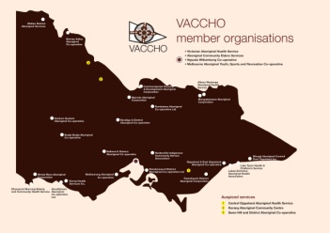
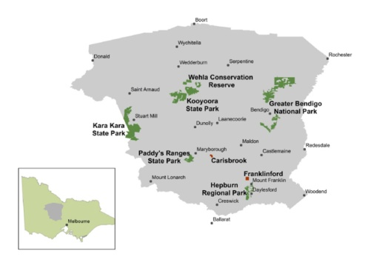
Bendigo & District Aboriginal Cooperative (BDAC) is an ACCO (Aboriginal Community Controlled Organisation) registered as a member under the umbrella of VACCHO (Victorian Aboriginal Community Controlled Health Organisation) and represented nationally through NACCHO (National Aboriginal Community Controlled Health Organisation).

BDAC was founded to represent and provide services to Aboriginal and Torres Strait Islander people living on Djaara Country.

BDAC has a responsibility to ensure growth of services, development of our Aboriginal and Torres Strait Islander community, better and improved health outcomes for our people, improved quality of life and be a lead agency in providing self-determination employment and career pathways for Aboriginal people.

LOCAL WORK ENVIRONMENT
Bendigo and District Aboriginal Co-operative provides a range of specialist services for Community living on Djaara Country including a Medical Clinic, Health and Wellbeing, Family and Community Services, and Kindergarten.

POSITION OBJECTIVE
BDAC’s Adolescent Violence in the Home (AVITH) Program is funded by the Department of Families, Fairness and Housing (DFFH).

The Adolescent Violence in the Home (AVITH) Program provides a specialised, culturally safe, trauma informed and therapeutic support to young people and their families, who are currently at risk of or have been impacted by Adolescent Family Violence.

The AVITH Therapeutic Practitioner will work alongside First Nations young people and their families providing educational support, enhancing adolescent development and support the safety of all family members.

BDAC’S VISION AND CORE VALUES
“Empowered generations belonging to strong families, culture and community”.

Our Lore refers to the stories, customs, beliefs, and spirituality of our People. Our Lore guides our work and has been passed down through generations by our ancestors and knowledge holders. Our five LORE principles are:
- We keep our focus on Community priorities.
- We are brave.
- We think outside the box.
- We create a safe, caring, and supportive environment.
- We are accountable.

Please refer to our https://www.bdac.com.au/our-strategy for further information about our underlying principles within the BDAC Strategy.

KEY POSITION RESPONSIBILITIES
Primary  Responsibilities | The AVITH Therapeutic Practitioner will engage with Aboriginal and/or Torres Strait Islander young people and families in a culturally safe and competent way.  The AVITH Therapeutic Practitioner will:  - Have sound understanding of the history of colonisation and resulting impacts on Aboriginal and/or Torres Strait Islander families  - Provide MARAM risk assessments to families with a special focus on MARAM framework and safety planning to families and young people where there is adolescent violence present in the home  - To support families to have their safety needs met, alongside of opportunities to promote and enhance their wellbeing and healing needs  - Work with families to ensure their cultural needs are identified early and embedded into practice  - Provide wraparound and practical support for families in a variety of settings  - Participate in the development of family plans using a wraparound approach and participating in ongoing review of family plans  - Ensure that all therapeutic work is delivered with a cultural lens  - Maintain quality and up to date data base information that meets privacy and legislative requirements  - Participate in team meetings, group supervision and team planning  - Provide primary and secondary consultation to internal professionals and families experiencing adolescent violence in the home  - Liaise and network with internal and external services to maintain relevant links and networks to strengthen services for young people and their families
General Responsibilities | - Model and abide by BDAC Values, Code of Conduct, Policy, and Procedures.  - Participate actively in and facilitate supervision and professional development activities.  - Ensure that you participate in team meetings, staff meetings and other community activities as requested.  - Ensure that you adhere to legislative requirements.  - Ensure that you report any risks identified immediately to your line manager.  - Participate within the team to ensure performance against expectations including performance management and staff development, in accordance with BDAC’s policies and procedures.  - Ensure that all staff are provided with and operate in a safe environment in accordance with BDAC’S OHS policies and procedures.  - Participate in Continuous Quality Improvement (CQI) activities.

COMMITMENT TO SAFETY
- All children have the right to be children and live free of abuse and neglect, so they can grow, learn, and develop. Everyone within BDAC is responsible for ensuring a culture of child safety, preventing child abuse, and abiding by the Child Safe Standards.
- BDAC is committed to the health and wellbeing of its employees and stakeholders.
- BDAC has a zero tolerance to all forms of violence.

KEY SELECTION CRITERIA
- Knowledge and understanding of Aboriginal cultures and the ACCO environment
- Demonstrated experience and expertise in delivering culturally safe and trauma informed therapeutic interventions to Aboriginal and/or Torres Strait Islander families
- Detailed knowledge of family-focused approaches which work to heal complex trauma
- Ability to work in a team and collaboratively with others
- Experience in Family Violence risk assessments and safety planning for survivors of family violence
- Excellent communication skills and an ability to develop trusted relationships with First Nations community members
- Demonstrated experience in referring to and collaborating with other local service networks
- Demonstrated willingness to participate in professional development opportunities
- Demonstrated ability to engage and work with a diverse range of stakeholders
- Excellent time management skills with the ability to meet deadlines
- Strong computer skills, ability to use a range of software and IT based reporting systems

Preferred / Desired / Mandatory Education, Training and/or Competencies.
- Recognised Social Work degree or a similar welfare or behavioural related degree which includes: a) a primary focus on child development, human behaviour, family dynamics and/or impacts of trauma; and preferably, b) practical component such as counselling or case work practice
or
- Recognised Diploma of Community Services Work, or similar qualification which is studied over a minimum of two academic years of full-time study (or part time equivalent) and includes: a) a primary focus on child development, human behaviour, family dynamics

CONDITIONS OF EMPLOYMENT
- Must pass a Criminal Police Record Check.
- Must pass and provide copy of Working with Children’s Check (or Teachers Registration if applicable).
- Must hold current full Victorian Drivers Licence and provide a copy.
- Must have the right to work in Australia.
- Must pass an Employment History check; and
- Must have and maintain a commitment to child safety, equity, inclusion, and cultural safety.
- Vaccination Policy: all staff are encouraged to be vaccinated against whooping cough, measles, mumps, and rubella (MMR) (if not immune), influenza (annually), hepatitis A and B, chicken pox (if not immune); shingles (for eligible people), and COVID-19. It is expected that Clinic and kindergarten staff will be vaccinated against the above diseases and will be required to complete a Vaccination Consent Form. It is also expected that Clinic staff will be vaccinated again diphtheria, tetanus and pertussis (DtP).

EMPLOYEE STATEMENT
I have read, understood, and accepted the above position description of the AVITH Therapeutic Practitioner.

EMPLOYEE NAME: ……………………………………………………………………..

SIGNATURE: …………………………………………………………………….

DATE: …………/………..../…………..

